Q1)

Code:

Flour packing problem

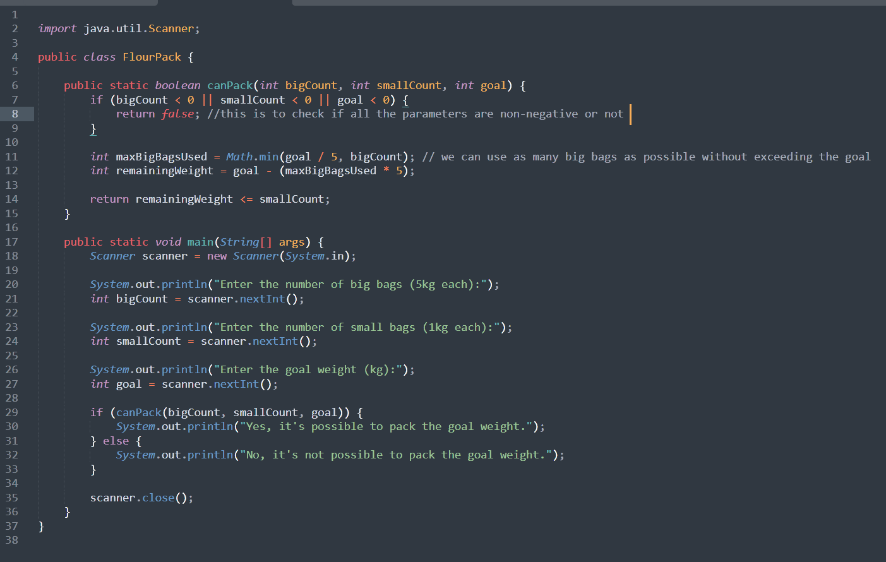

Output screenshots:

If canPack(1,0,4)

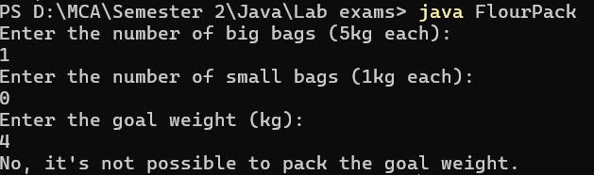

canPack(1,0,5)

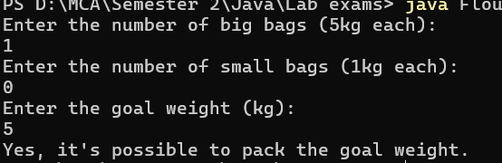

If canPack(0,5,4)

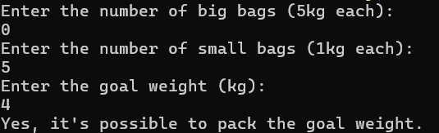

If canPack(-3,2,12)

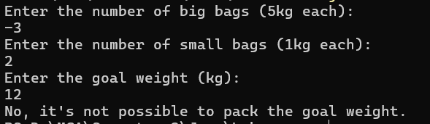

If canPack(2,0,9)

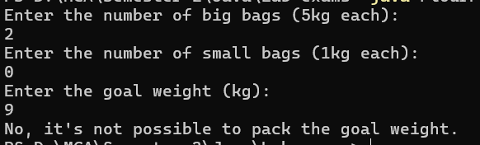

Q2)

Code:

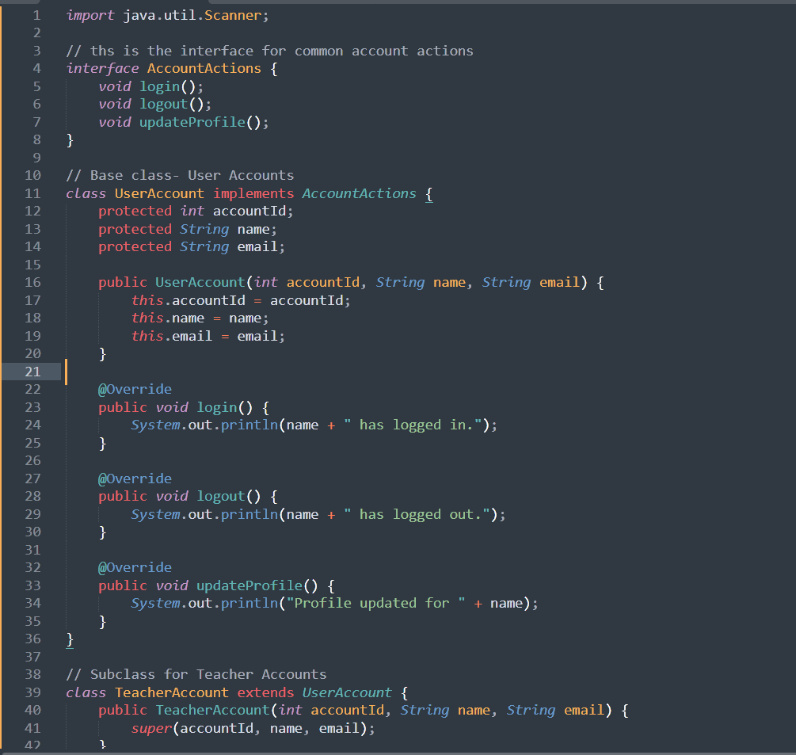

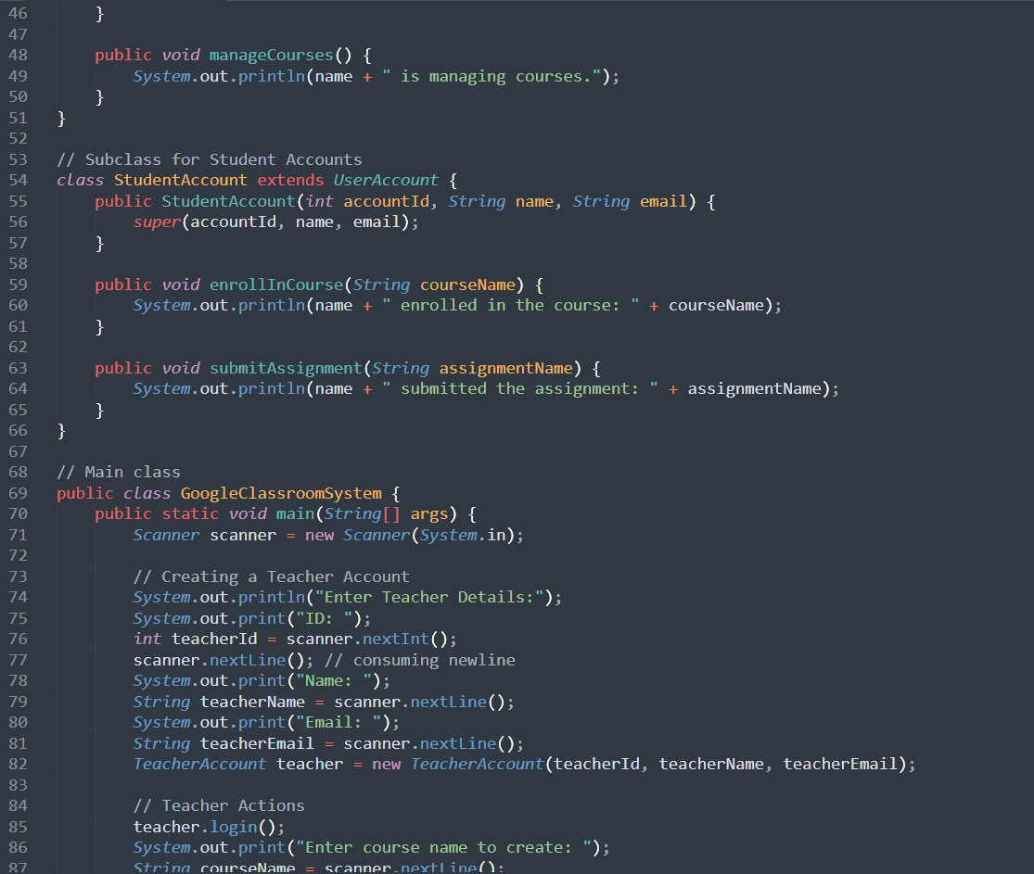

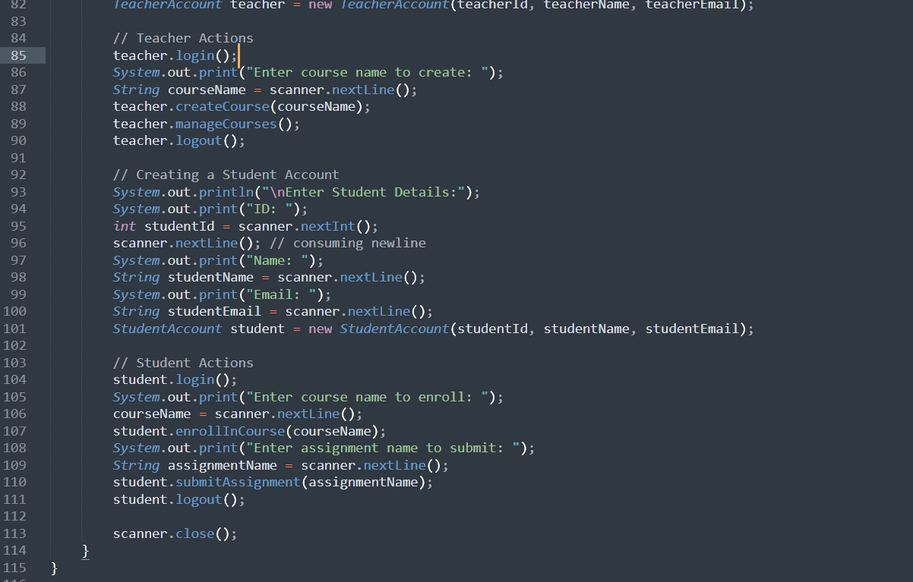

Output:

